

**Submitted by:**

Fahad Asif

**Referred to:**

Sir. Muhammad Affan

**Roll no:**

462895

Fundamentals of Programming

Lab Manual 8

Task 1

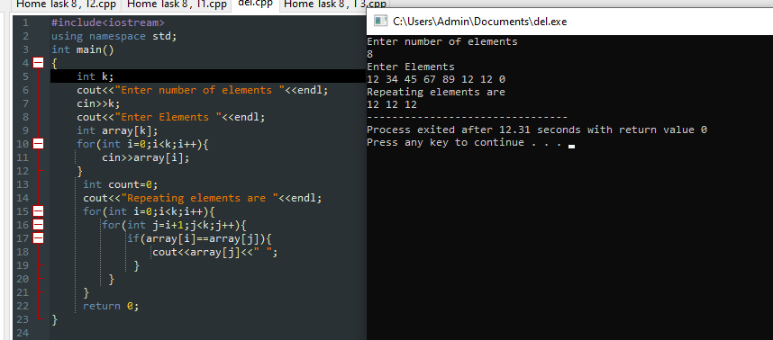

Task 2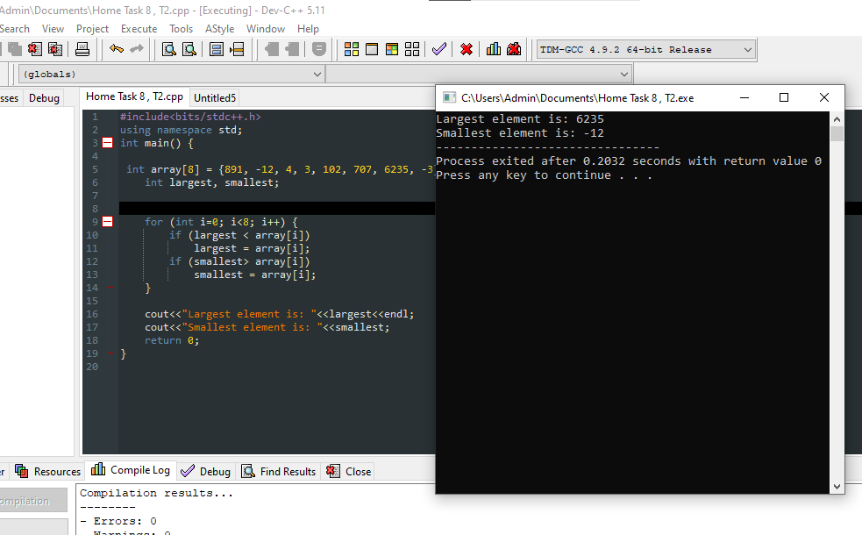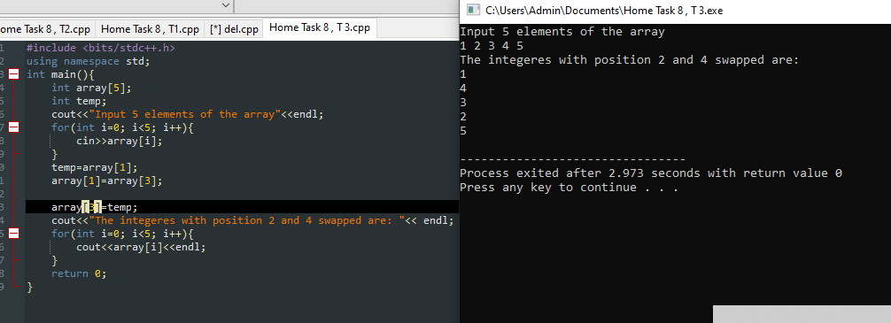**Task 3**